Contact: Jonina Costello / jcostello@full-throttlecom.com
Jason Bear / jbear@full-throttlecom.com
Phone: (805) 529-3700

RINEHART TARGETS® R100 ARCHERY SHOOT COMES TO MOBERLY, MO APRIL 29-30

Fun for All-Age Archers and Their Families; Event Features 100 Different 3D Targets to Shoot

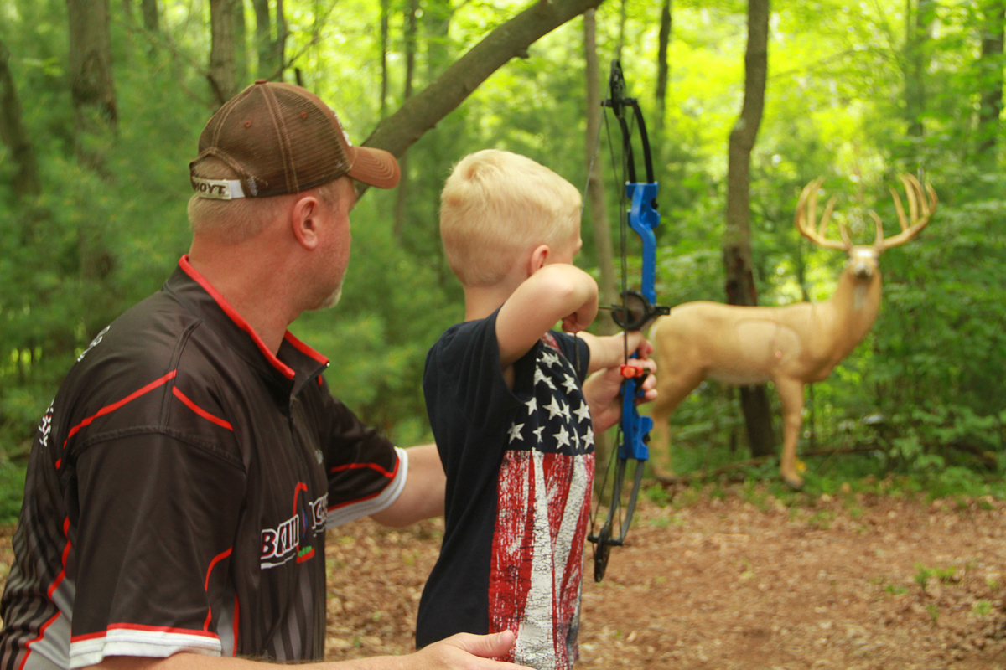
Janesville, WI — Rinehart Targets®, manufacturers of the most durable and lifelike 3-D archery targets in the industry, has announced its wildly popular Rinehart R100 Shoot will be coming to Moberly, MO April 29-30. The family-friendly shooting event will be hosted by Show-Me Youth Archery at Rothwell Park. So, come and shoot, win prizes and have fun!

A full two-days of shooting fun, the event is a jam-packed weekend of competitions – from serious to the wacky. The event features 100 unique targets including 67 targets from Rinehart’s 3D line ranging from mosquitos to lions and everything in between. There will also be 33 specially made custom targets that you will only see at R100 Shoot events such as life-size giraffes, zebras, elephants and more.

The R100 Shoot is open to adults and kids of all ages. Pre-register for the event at www.r100.org and save up to $10. Pre-registration closes 48 hours prior to event start, however participants can also register onsite beginning Saturday at 7:30 a.m. with the first event taking place at 8:00 a.m. The event ends on Sunday at 3:00 p.m. with an award ceremony where shooters have the chance to take home prize gear packages provided by event sponsors like Matthews, Darton Archery, AAE, Treelimb Quivers, Sword Sights, Vortex and more!

Don’t miss some of the fun events including the Milk Jug Shoot and the Super Ten. A novelty shoot, the Sunday Milk Jug Shoot features two one-gallon jugs of water hung from a pulley system. The goal – to empty your jug before everyone else! Only 16 archers compete in this event. Nab one of those 16 spots, at the pre-qualifier event on Saturday.

Since 2003 the Rinehart R100 has been providing archery lovers with an event designed for participants of all levels and ages. The event is focused on family fun and introducing new shooters to the great sport of archery. The annual multi-city event takes place through the Spring and Summer. Last year the events drew more than 9,100 archers. This year, the tour will stop in 14 cities across the United States including Fresno (Friant), Calif.; Moberly, Mo; Staunton, Va.; Coshocton, Ohio; Mount Airy, N.C.; Alloway, N.J.; Sturbridge, Mass.; Shartlesville, Pa.; Wabash, Ind.; Hutton, Ill.; Sparta, Wis.; Saginaw, Mich.; Fayette, Iowa; and Calhoun, Ky. For more information on the shoot, rules, and event registration, visit: http://www.r100.org.

If you plan on attending, let us know on the R100 Moberly, MO Faceboook Page! We also invite you to post your R100 event pictures on Facebook @RinehartR100 using #R100shoot2017 to participate in R100 giveaways and for a chance to be featured on the page.

About Rinehart Targets
Since 1999 Rinehart Targets has been manufacturing the Best Archery Targets in the World. Today, the company continues to expand on its wide range of archery targets offered including: 3D Targets, Cube Targets, Crossbow Targets, Bag Targets and Range Targets, along with its newly added line of archery decoys. For more information about Rinehart Targets, visit: rinehart3d.com.

Connect with Rinehart on social media:

Editor’s Note: For press releases and hi-res images from Full-Throttle’s wide range of clients, please visit our online press room.

